**ENGN2605 Lab 06**

**Instructor: Prof. Benjamin Kimia**

**Name: Kuan-Min Lee**

**Brown ID: 140481859**

**Problem 1. Image Stitching from Two Views:**

In this section of the experiment, it involves in utilizing SIFT features on one pairs of images, using the SIFT features on one image as the reference to the second image to find the corresponding feature locations and stitching two images into one. The following shows the results of three pairs of images:

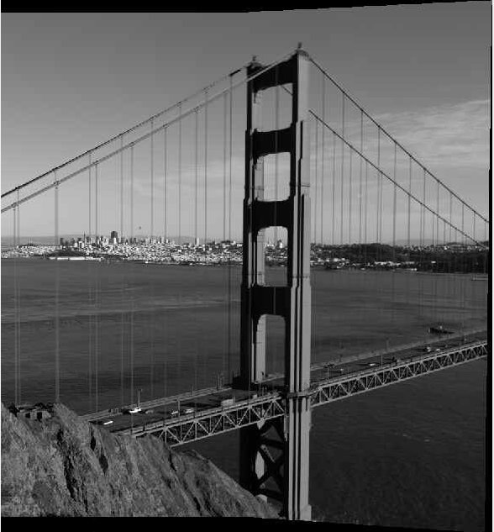

Figure 1: Golden Gate Bridge View of Stitched

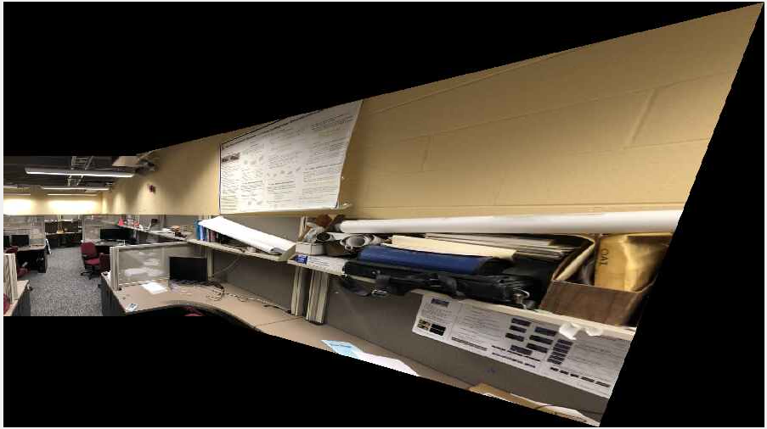

Figure 2: LEMS Lab View of Stitched

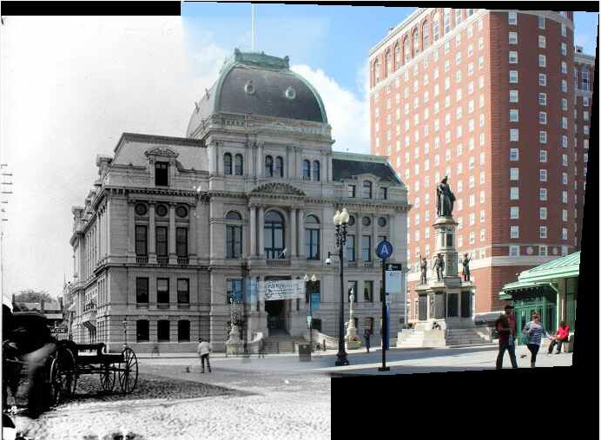

Figure 3: Providence City Hall View of Stitched

**Problem 2. Image Stitching from Triplet Views:**

This section involves in using the same idea from problem 1 but using on a pair of three images to form a stitched image. Instead of just utilizing SIFT features on the two images, we need to first implement SIFT features on the first two image and stitched them together. After that, the SIFT features will be extracted again from the stitched image from the first two images and the third image. These SIFT features will then be utilized as the correspondence to form the final stitched image. The following are the results of the two pairs:

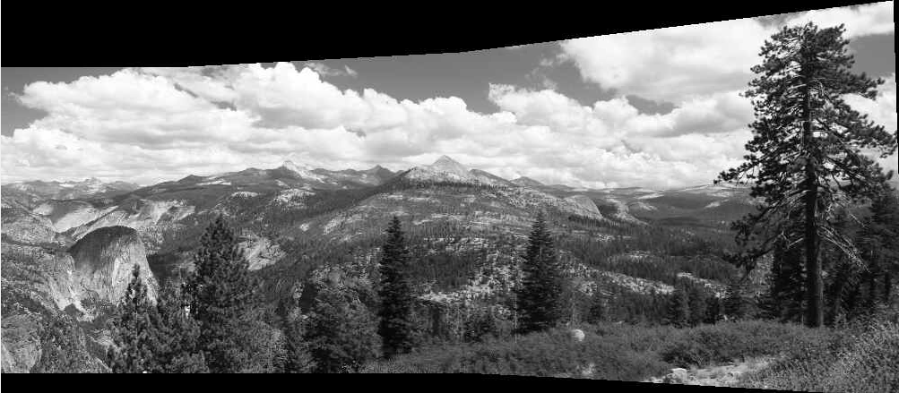

Figure 4: Mountain View of Stitched

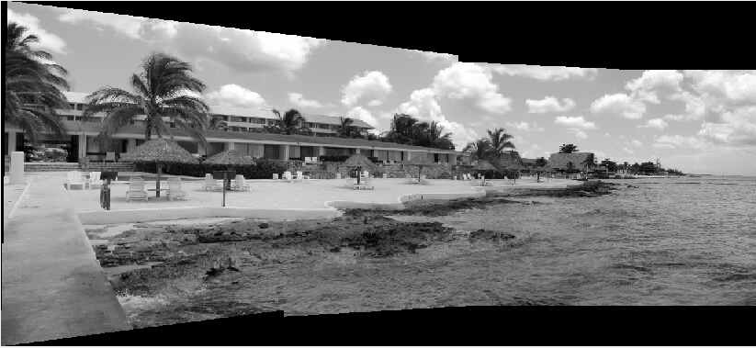

Figure 5: Beach View of Stitched

**Problem 3 Answer the Following Questions**

**Question 1:** The RANSAC posses the advantages of assuming that there’s correct and incorrect feature correspondence in the matching. In the least square solution, the solution takes every point indiscriminative. Therefore, the incorrect outcomes will also affect the final solution. With RANSAC feature, it takes the number of inliers into account and pick up the best solution over all iterations. With this feature, it can mitigate the affect coming out from the error correspondence.

**Question 2:** In the scenario that the four sampled points are within the same line, the rank of the homography matrix will then become a non-full rank matrix. In this case, the homography matrix will not be able to span the whole space and determine the values of homography.